Newsletter
Issue 13

8 December 2023

Dear Parents and Carers

STEM Workshops
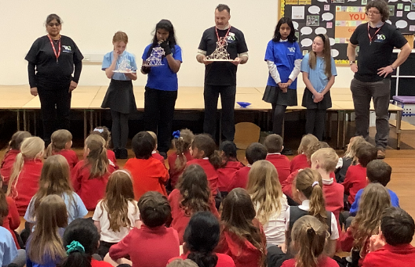
On Monday we had some engineers visiting our school to talk to the children about the M3 motorway development. Each class in KS2 enjoyed a fun workshop with the engineers where they explored building different structures out of marshmallows and sticks. The children tested their structures for strength and the engineers were really impressed with their creativity and dynamic models.

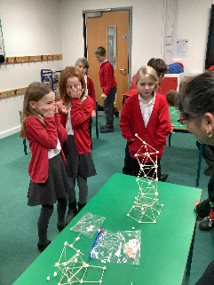
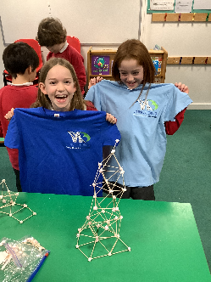
The children had to design a structure that could withstand an earthquake, but also that was the tallest, using only mini marshmallows and cocktail sticks! Keira and Pria made the tallest tower,that could survive the earthquake (table rocking!) at 42 cm.

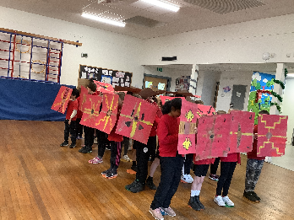

Other Activities in School
Year 4 learnt how to march like the Romans, and had to defend themselves against a loud and rebellious Celtic Tribe, also known as our Year 3 Hares class!!.

Hockey Training
Years 3 and 4 have been enjoying hockey training, taught by Angie from Winchester Hockey Club. The following students were awarded certificates for achievement over the last 6 weeks.

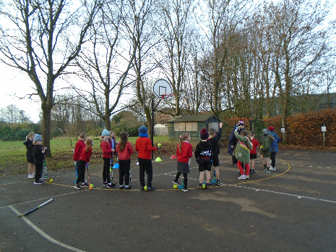
Year 3: Nefeli Kyra
Liam William
Matilda

Year 4: Esher Nina
Kylan Olivia
Henry

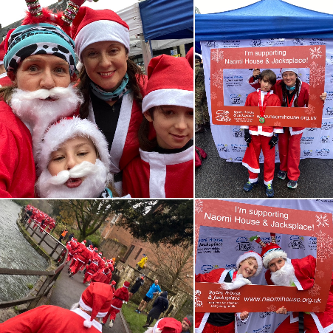
Santa Fun Run
Well done to our year 5 students Hannah and Wilf for taking part in the 5km Santa Fun Run in Winchester last Sunday! They had a jolly good time dressed up as Santa and did a great job fundraising, collecting over £460 for Naomi House & Jacksplace. These are hospices supporting life-limited and life-threatened children, young adults, and their families from across the central South of England.

Christmas Hampers
The PTA are organising the Christmas Hampers again this year. The colours for each class are:

Nursery Blue
Squirrels Silver
Ladybirds Red
Bumble bees Pink
Hares Green
Foxes Purple
Herons White
Kingfishers Gold

Please bring your hamper donation to the class teacher. Tickets will be on sale shortly. Thank you for your support. The draw will be taking place on Wednesday 13 December after the carol service.

Otterbourne Panto
The Otterbourne Theatre Company invite you to join them for their 2024 Family Pantomime, The Little Mermaid. They've got a fishy script for this scaley story, amazing costumes and lots of energy to entertain you! Tickets are only £10 each on Friday evenings and £12 on Saturday and Sunday performances. Evening performances start at 7.30pm on 12th, 13th, 19th and 20th January. The matinee performances start at 2.30pm on 13th, 14th, 20th and 21st January. Tickets are available online, via social media or via www.otterbournetheatre.com. They are also staging a relaxed, signed performance at 11am on Sunday 14th January - see our website for more details.
Don't delay - grab your diary and get your tickets booked!!

Breakfast Club
A reminder that there will be NO Breakfast Club next Friday, 15 December.

Pantomime
A reminder that the whole school (not Nursery class) will be attending the Pantomime next Thursday. The buses will be leaving school at 9.10/9.15am at the very latest. Please ensure that your child is in school by 8.45 for registers and lunch orders to be taken. We will not be able to wait for any late children due to the performance time.

The only lunch options on that day will be picnic boxes. The choices will be Red: Ham or Green: Cheese picnic box. Thank you in advance.
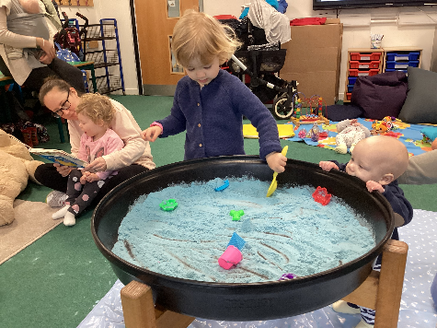
Little Tots in the Hub
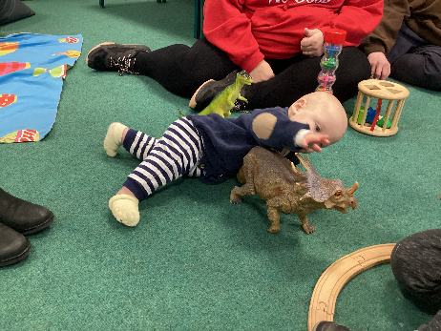
We have had a great response to our new club which runs on Thursday mornings. The children have enjoyed the activities available and enjoyed making new friends.

We will not be running the club next Thursday, 14 December due to the school attending the Pantomime but will return in the New Year on Thursday 11 January 2024.

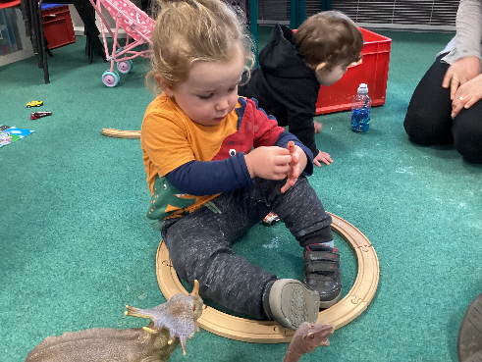

Christmas Dates
Some dates for your diary –

Monday 11 December - Rock Steady Concert – 2.30pm
Tuesday 12 December – 2pm Nursery and Year R Nativity
Wednesday 13 December - Christmas Carols – 3.00pm (KS1 and KS2)
Thursday 14 December - Whole school trip to Pantomime (not Nursery)
Friday 15 December - No Breakfast Club

Charity Christmas Cards
If you would like to support a charity of your choice when buying Christmas Cards this year, pop along to the Brookes Shopping Centre in town as they are selling them from a shop unit in there. Many different charities are represented.

Christmas Holiday Lunch Scheme
Winchester Basics Bank are running a holiday lunch scheme over the Christmas break. This is designed to replace the hot meal that children would receive at school during term time. The scheme will provide food for ten meals per child. For more information or to register please visit: https://winchesterbasicsbank.co.uk/get-help/ or email: holidaylunch@winchesterbasicsbank.co.uk or telephone 01962 864720.

Intergr8 Christmas Camps
Intergr8 Dance who provide our Dance and Cheerleading Classes are running Christmas Camps the first week of the Christmas Holidays. Each day will be a different theme associated with Christmas.

The camps will consist of Street and Theatre Dance, Arts and Crafts and Games. The cost will be £30 per child per day or £120 for the week.

There are also free places for children on are eligible for free school meals.

For more information email: info@integr8dance.com or call 01962 808398.

Cricket Hoppers
Cricket Hoppers are running a Christmas Camp at Kings’ School – December 18th – 21st (9.30 – 12.30) For more information on these fun mornings go to www.crickethoppers.co.uk or email admin@crickethoppers.co.uk to enquire about places available.

Learning Behaviours
We have held this week’s Learning Behaviours assembly. This is where each teacher chooses a child/children that has demonstrated the chosen learning behaviour of the week. The teacher shares with everyone what the child has done and then we all celebrate their achievement. This term we are looking at curiosity. The children who were chosen this week were:

Year One Francis
Year Two Codi
Year Three Orla
Year Four Henry
Year Five Taylor
Year Six William

School Lunches
Thank you to everyone for settling their lunch accounts, however the lunch debts are still high - please could you ensure that your account is kept up to date. For your information the money owed per class is as follows:-
Hares £ 154.33
Foxes £ 36.20
Herons £ 184.10
Kingfishers £ 205.30
Nursery £ 138.40

From Monday 18 September your child will not be able to order a school lunch if the debt is above £10.00 – if the debt is over £10.00 they will need to bring in a packed lunch. Please can you arrange to clear your Lunch accounts as soon as possible.

If you would like an up to date statement of your child’s account please contact the Admin Team. If you have not yet registered to pay online via Scopay and would like a copy of your login details please email us and we will be happy to help. We would appreciate it if all accounts, including any outstanding Breakfast Club and After School Club accounts, could be settled as soon as possible. Please ensure that your After School Club Account is up to date as we employ extra staff for this club. If you would like an up to date statement please contact the school office.
Thank you for your continued support.

Yours faithfully

Mrs Bordoli
Interim Headteacher

Dates for your diary (new dates in red)

Rocksteady Concert 11 December 2023
Nursery and Year R Nativity – 2.30pm 12 December 2023
Christmas Carols 13 December 2023
Whole School Trip to Cinderella 14 December 2023
No Breakfast Club 15 December 2023
School breaks up for Christmas 15 December 2023
School returns for Spring term 2 January 2024
Open Morning (9.30am) 5 January 2024
Year R school applications close 15 January 2024
Inset Day 19 February 2024
Inset Day 28 June 2024
Inset Day 1 July 2024

